Other Careers
Only around 20% of graduates actually go on to seek a career as a professional Psychologist, leaving the majority to go into more general employment after their degree.
If a psychology-related career is not for you then there are plenty of other options available to you. As a Psychology degree is so diverse, it provides graduates with a range of transferable skills which employers will value!
What are these ‘transferable skills’?
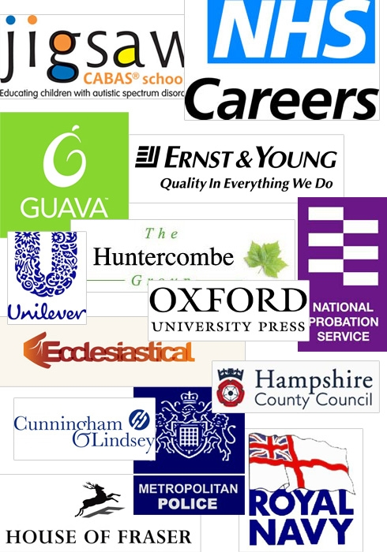
Throughout your degree you learn about how the human mind works and its influence on behaviour, allowing you to develop excellent interpersonal skills as well as the following:
- Expertise in oral and written communication
- Time and task management
- Working well independently and within a team
- Ability to handle complex written and numerical information
- Planning and organisation
Do I still need work experience?
It is always a good idea to get as much work experience during your studies as possible as this will make you stand out to an employer.
- It demonstrates that you have a strong work ethic. Skills learnt from your degree have been applied to the real world and therefore have been enhanced.
- It allows you to network with a wide range of people and this could later increase your chances of a permanent role.
- Trying out different work experience roles will allow you to see which kinds of things you like the most, giving you more of an idea of the direct career path you wish to take.
Make the most of the University’s Career Destinations teams as they can offer CV advice, mock interviews, internships and more.

